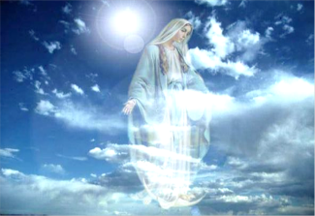***Parish Newsletter***

**OUR LADY OF RANSOM**

D:\Pics\P4091.tif**Third Sunday of Advent - Year C**

**Psalter Week 3 – 11th / 12th December 2021**

***Come Lord Jesus, shake the tired foundations of our crumbling institutions, breathe upon our troubled world. Break the rules that keep you out of all our sacred spaces and institutions, and from the dust and rubble, gather up the seedlings of a new creation.***

***Come Lord Jesus, enflame once more the dying embers of our weariness. Shake us out of our complacency. Whisper our names once more, and scatter your gifts of grace with wild abandon. Break open the prisons of our inner being, and let your raging justice be our sign of liberty.***

***Come Lord Jesus, lead us to places we would rather not go. Expand the horizons of our limited imaginations. Awaken in our souls dangerous dreams for a new tomorrow, rekindle in our hearts the fire of prophetic enthusiasm.***

***Come Lord Jesus, your justice outwits international conspiracy, your light outshines religious bigotry, your peace can halt our patriarchal hunger for dominance and control, your promise invigorates our every effort: to create a new heaven and a new earth, now and forever****.*

***Diarmuid O’Murchu (slightly adapted****).*

Shaking foundations, breaking rules, awakening to dangerous dreams – rocking the boat and making waves. Radical stuff. Do we like these people? Or would we rather our little securities and comforts? Diarmuid’s prayer describes John the Baptist’s kind of thinking: a man of raging justice and dangerous dreams. Disturbing the comfortable and comforting the disturbed. Jesus follows these radical and revolutionary teachings of John the Baptist, taking them to new dimensions, new depths and new horizons e.g. ‘love your enemies’. Can we follow this real Jesus?

It is these radical people who will co-create a new heaven and new earth. If our world is to be saved *they* will be responsible for saving and transforming it into a better place. Comfort and security lovers will do precious little, they are often too self-centred, they are boring creatures of habit, set in their ways who will never grow the world up.

How radical are we prepared to be in following Our Lord so as we can take our part in transforming this world to a better place?

***God Bless, Fr. Paul***

***All Masses and Church Services are now Live Streamed.***

***To take part please go to*** [***https://stream.seccomgroup.com/channel/olor***](https://stream.seccomgroup.com/channel/olor)

***Masses can be watched “live” or later as a recording.***

**C:\Users\Parish Office\Desktop\SIGNS, SYMBOLS & SAINTS\LIT_A_CH\01\AC_03D.TIFTODAY’S READINGS:**

Zephaniah 3:14-18

**C:\Users\Parish Office\Desktop\SIGNS, SYMBOLS & SAINTS\LIT_A_CH\01\AC_03G.TIF**Isaiah 12:2-6

Philippians 4:4-7

Luke 3:10-18

***This week Fr Paul will say Mass for the following intentions:-***

|  |  |
| --- | --- |
|  | **MASS INTENTIONS** |
| **Saturday 11th Dec.** |  |
| **5.30pm Mass** | Parish Community |
| **Sunday 12th** | **THIRD SUNDAY OF ADVENT (Gaudete Sunday)** |
| **8am Mass**  **9.30am Mass** | Judy Wood RIP (Pat Wood)  Prayer Board Intentions |
| **Monday 13th** | **St Lucy** |
|  | Hemming Family RIP |
| **Tuesday 14th** | **St John of the Cross** |
|  | Holy Souls RIP |
| **Wednesday 15th** |  |
| **10am** | ***Eucharistic Service*** |
| **Thursday 16th** |  |
|  | Alice Allso RIP |
| **Friday 17th** |  |
| **10am** | ***Eucharistic Service*** |
| **Saturday 18th** |  |
| **5.30pm Mass** | Sharon Hillman RIP (Marie & Colin Griffin) |
| **Sunday 19th Dec.** | **FOURTH SUNDAY OF ADVENT** |
| **8am Mass**  **9.30am Mass** | Sir David Amess RIP (Sally McNamara)  Parish Community Ints |

|  |  |
| --- | --- |
| **PARISH PRIEST**  Father Paul Fox  50 London Hill, Rayleigh  Essex SS6 7HP  ***01268 382 499***  **www.olorchurch.org**  email: [***rayleigh@dioceseofbrentwood.org***](mailto:rayleigh@dioceseofbrentwood.org) | **Public Mass times:**  **Saturdays 5.30pm**  **Sundays 8am & 9.30am**  **Wednesdays 10.00am**  **Fridays 10.00am**  *Please be aware - Times and days of Masses are subject to change.* |

**Our Parish is part of The Brentwood Diocesan Trust, Registered Charity Number 234092**

**Sunday Obligation**

The Sunday Eucharist is a gift; as God’s holy people we are called to praise and thank God in the most sublime way possible. When the Church speaks of the Sunday obligation, it reminds us that attending Mass is a personal response to the selfless offering of Christ’s love. At this time, we recognise that for some people there may be certain factors which hinder attendance at Sunday Mass. The pandemic is clearly not over. The risk of infection is still present. For some, there is legitimate fear in gathering together. As your bishops, we recognise that these prevailing circumstances suggest that not everyone is yet in the position to fulfil the absolute duty to attend freely Sunday Mass. Responding to the Gift We now encourage all Catholics to look again at the patterns which they have formed in recent months with regard to going to Mass on Sundays. This would include consideration and reflection about what we might do on Sundays, such as sports or shopping, or other leisure and social activities. This review, and the decisions which arise from it, fall to every Catholic and we trust this will be done with honesty, motivated by a real love for the Lord whom we encounter in the Mass.

From the Bishops’ Conference.

**CHRISTMAS FLOWERS**

Donations towards the cost of flowers to decorate the Church at Christmas will be gratefully received. Please leave at the Presbytery or in the wall collection box at the back of Church.

Many Thanks, from the Flower Team.

**FREE!! KEEP CHRIST IN CHRISTMAS POSTERS**

These have been kindly provided by the Knights of St. Columba.

Copies available from the Church Porch – please take and display at home.

**The Bethlehem Nativity Group (TBNG)**

**A missionary from Bethlehem, The Holy Land will visit us next weekend, 18th-19th December** to briefly talk about the Holy Land and sell religious articles made out of Olive Wood from the Holy Land to help and support the poor Christian families, any help you could give to them it will be highly appreciated.

**CONFESSIONS**

**Fr Paul will be available in Church for Advent Reconciliation on:**

**Sunday 19th December after 9.30am Mass until 11.30am**

**and**

**Monday 20th December between 7.30 -8.30pm**

**and**

**Wednesday 22nd December after 10am Mass until 11.30am.**

No need to book – just turn up. If no-one is in the church, please call at the presbytery.

image028**Christmas MAsses – Please read carefully**

**Friday 24th December - Christmas Eve Masses as follows:-**

**Christmas Eve 6pm (Family Mass)**

This Mass is for families (including grandparents) with children.

Adults with no children are encouraged to attend one of the other Christmas Masses.

**Christmas Eve 12pm** **– Midnight Mass**

**Saturday 25th December, Christmas Day - Masses at 8am and 10am**

**Sunday 26th December, The Feast of the Holy Family - Masses at 8am and 10am**

**THE REPOSITORY... Come and Look!**

**Please come and see all our Christmas stock in the repository.**

We have lovely Christmas cards and many lovely Nativity items available which you may wish to purchase for yourselves or as a gift for someone. We look forward to seeing you.

**PLEASE SAVE YOUR USED STAMPs….**

Please save your used stamps over Christmas and leave them in the container in the Porch.

These are being collected for the MS charity. Thank you in advance, Ruth Fitzgerald.

**Brentwood Catholic Children’s Society**

***Tree of Angels:***

[**https://www.bccs.org.uk/christmas/tree-angels**](https://www.bccs.org.uk/christmas/tree-angels)

### **“Alternative Gifts” this Christmas**

### St Mother Teresa of Calcutta said, “It is Christmas every time you let God love others through you.”

### As part of Advent, we naturally reflect on our Christmas giving. Many charities now offer inventive and wonderful ways to support their work, as a gift to others – you can buy goats or bees, help preserve sections of rainforest, and much more. To help in your search for such gifts our Diocesan Caritas has brought a range of charity details all together on one page, and you will find it at: <https://www.caritasbrentwood.org/christmas/>

**HOME HELP**

One of our loyal and trustworthy parishioners (CRB checked) is offering to do all sorts of housework - if you are interested please phone Linda 07949 169276.

**BRASS CLEANING**

Anyone interested in cleaning Church brass (candlesticks etc.) on a regular basis please speak with Fr Paul.

**LIFTING OF RESTRICTIONS**

If you are strict about social-distancing, the pews on the right hand side (as we face the altar) are largely reserved for those who wish to do so.

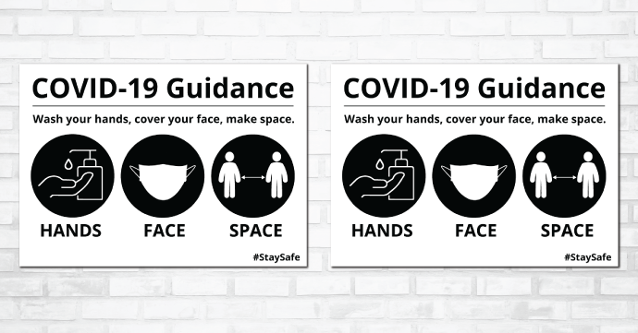**Public Masses:**

**Face Coverings** – **please** continue wearing a face covering as a mark of respect for one another’s health and protection.

Please **do not come** if you have symptoms, sniffles, sneezes, coughs, immunity issues etc.   
Use common sense and **think** **of others**.

**Social Distance should be maintained as much as possible – again – out of mutual respect.**

Please continue to follow **only** the directions of the Stewards.

**Holy Communion** only to be received on the hand for added protection.

The church will continue to be both cleansed and sanitised regularly

**OFFERTORY CONTRIBUTIONS**

***Thanks to all who continue to support our parish financially.***

**DONATIONS USING QR CODES**

To avoid having too much cash lying around, it is now possible to make donations in Church using your mobile phone and QR codes.

***There are notices in the porch for contributions to the parish***

**ONLINE DONATIONS**

To make a donation online go to <https://stream.seccomgroup.com/donations/olor>

**GIFT AID /ENVELOPES****.** Some people have started donating to the parish online during lockdown. If you are a taxpayer it’s worth a reminder that we could get **an extra 25%** on your donations if you sign up to the Gift Aid scheme.

***Please contact Sandra our Gift Aid Co-ordinator (***[***olorgiftaid@hotmail.com***](mailto:olorgiftaid@hotmail.com) ***/ 01268 772998) if you have any questions.*** Thank you.

**MANY THANKS FOR ALL THE MASS INTENTIONS AND CONTRIBUTIONS**

Please note: At present we have a large number of outstanding Mass Intentions, which takes us **to the New year.**

****

**PLEASE PRAY**

For all the sick members in our Parish and all our relatives and friends.

**✟ ANNIVERSARIES ✟**

Kindly pray for Anne Donaghy, Daphne Gooch, Katie Bundy, Joan Denny, Dorothy Whitty, June Turner and Finbarr McQuaid. May they rest in peace.

***✟✟ PLEASE REMEMBER IN YOUR PRAYERS…***

***Jim Hollington*** *who died recently. Please keep Carol and the family in your prayers* ***✟✟***

**MASS and Sympathy cards …**can be obtained at the repository shop and the presbytery. Please contact Fr. Paul to arrange a convenient time to come, choose, collect and pay for the cards if the shop is closed*.*

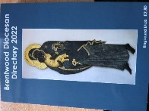**2022 Brentwood Diocesan Directories**

**Now available from the Porch**

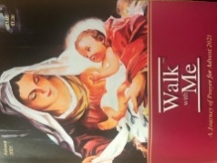**or Presbytery - £2.80 each**

**“Walk with Me - Advent”**

**Available now. £1 each.**

**Newsletters**

**A few printed newsletters will be left on the shelf outside the presbytery after each weekend Mass.** These are primarily designated for anyone who has no email access.

**If you are able to print off newsletters yourselves and deliver to anyone who can’t get out,** that would be a great act of charity. Thank you.

***If you, or anyone you know, would like to receive the newsletter by email each week, please in the first instance email a request to the parish office (***[***rayleigh@dioceseofbrentwood.org***](mailto:rayleigh@dioceseofbrentwood.org)***) and ask to be added onto the distribution list.***

***The newsletter will be emailed by the Saturday morning.***

**The Diocesan Lourdes Pilgrimage in 2022, led by Bishop Alan, will take place from Sunday 24 – Friday 29 July in Lourdes.**  Costs have not yet been confirmed.

This will be the first time in three years that the diocese has returned to Lourdes. Brochures for the pilgrimage, which will include costs, will be available soon. If you would like further information now, please contact Cathy O’Connor, the Administrative Director: [cathy@dioceseofbrentwood.org](mailto:cathy@dioceseofbrentwood.org) or 07813 710070.

**BCYS Summer Lourdes Pilgrimage 2022: 23rd – 30th July 2022.**

Applications are **now open** for our summer pilgrimage to Lourdes for those in Years 11-13, with those of school leaver age (18+) invited to join us as young leaders. This is one of our most popular events and after a 2 year gap we are excited to be returning next year. The week is spent travelling alongside the main Diocesan pilgrimage as we assist the elderly and infirm with going to Masses and services, as well as visiting shops and cafes within the town. For those travelling with the BCYS the week will also include a retreat, reconciliation service, as well as social events and a party. Please see [www.bcys.net/events/sl22/](http://www.bcys.net/events/sl22/) for more information including visas, vaccinations and how to apply.

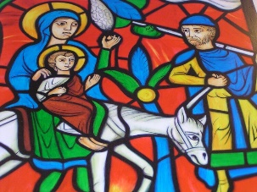**FAITH TALK ON THE CHRISTMAS GOSPELS:**

As Christmas draws closer we shall be reading the sections of the gospels commonly known as ‘infancy narratives’ with their stories of the births of John the Baptist and of Jesus.

The three parts of this talk consider Matthew chapters 1-2, Luke chapters 1-2 and John chapter 1.

**The videos are available free of charge on** [**www.whatgoodnews.org**](http://www.whatgoodnews.org)

They are given by Fr Adrian Graffy, parish priest, Scripture scholar and member of the Pontifical Biblical Commission.